USER’S GUIDE OF

**BETR Global**

Version 4.0

Edited by

Matthew MacLeod

Fangyuan Zhao

Stockholm University,

SE-106 91 Stockholm, Sweden

<https://github.com/BETR-Global/BETR-Global-4.0>

March 2020

Table of Contents

ACKNOWLEDGMENTS I

1. OVERVIEW 1

1.1 New features in BETR Global 4.0 1

1.1.1 Gas-particle concentration ratios of semi- and low volatility chemicals 1

1.1.2 A sub-grid cell correction 2

2. THE BETR GLOBAL MODELING STRUCTURE 2

2.1 Temporal resolution 2

2.2 Spatial resolution 2

2.3 Compartments 3

2.4 Mathematical formulation 4

3. Installation and Run BETR Global 4

References 5

# ACKNOWLEDGMENTS

Matthew MacLeod and Fangyuan Zhao acknowledges the following people for their contributions to the development of BETR Global.

Harald von Waldow, for implementing the Excel version into Python version (<http://betrs.sourceforge.net/index.html>).

Henry Wöhrnschimmel, for including the capability of high spatial-resolution simulations (7.5° and 3.75°); updating some input parameters in atmosphere, fresh water, ocean and soil; and introducing some new processes.

Recep Kaya Göktaş, for implementing a fast numerical ODE solver; and including an algorithm to track mass fluxes between compartments.

# 1. OVERVIEW

Berkeley-Trent Global (BETR Global) is a framework to model the fate and transport of organic chemicals in the environment. It was developed by re-implementing BETR-VBA in the Python programming language. The BETR-VBA created by Matthew MacLeod takes the form of a Microsoft Excel macro written in Visual Basic, and it has been used in various scientific studies.1-6 BETR-VBA works without any installation procedure on Microsoft Windows computers with MS Office installed. Its user interface (Excel) is familiar to many people and it produces nicely formatted output. BETR Global on the other hand is implemented in Python, is platform independent, has a command-line user interface, and the formatting and analysis of the output is largely left to the user. It runs about 20 times faster than BETR-VBA. It has been successfully validated against BETR-VBA and yields identical results.7

A design criterion of BETR-Research was its usability in a research context. It should be easy to modify and extend the model to explore new research questions. It is simple to use the model inside a batch script, for example to simulate many different chemicals or parameterizations. The output is directly available in Python data structures to facilitate post-processing, for example for sensitivity analysis and visualization. It is designed to be modular, yet consciously forgoes object-oriented techniques in favour of a simple code structure that is hopefully comprehensible to anyone familiar with a procedural programming language like Fortran, C, or BASIC. Next to the re-implementation of BETR-VBA, BETR Global is a framework to define completely new models, with arbitrary regions, compartments and transport processes. This framework can for example be used as a teaching tool to have students implement a simple model and experiment with it. Since BETR Global was introduced, it has been applied to analyse many different global-scale chemical pollution problems and successfully validated against measurements.8-11

## 1.1 New features in BETR Global 4.0

### 1.1.1 Gas-particle concentration ratios of semi- and low volatility chemicals

The long range transport of chemical pollutants in the atmosphere depends on their distribution between the gas phase and aerosol particles.10, 12 The old versions of BETR Global assume equilibrium partitioning of chemicals between the gas and particle phases. However, assuming equilibrium has recently been shown to overestimate the fraction of semi- and especially low-volatility chemicals in the particle phase.13 In BETR Global 4.0, we introduced a method that separates particles from gas phase, and particles are further divided into two types according to their diameters: fine particles (diameter < 1 µm) and coarse particles (1 µm < diameter < 20 µm). Diffusion of chemicals between gas phase and particle compartments are calculated using the approach described by Cahill and Mackay. 14

Compared with the old versions of BETR Global, new features in BETR Global 4.0 are:

* Three new compartments in each cell: coarse particle compartment in upper air, fine particle compartment in lower air and coarse particle compartment in lower air (Figure 2). The volume fraction of fine particle in upper air (free troposphere) is quite small described by Seinfeld and Pandis,15 so we only consider coarse particle compartment in upper air.
* Half-lives of fine and coarse particle compartment and activation energies in fine and coarse particle compartments are included in the document that describing physicochemical properties of chemicals.
* Constant environmental parameters includes fraction of organic matter in particles, volume fractions of particles and velocity of particles are updated. New parameter that is diameter of particle is added. In the old versions of BETR Global, organic matter fractions, volume fractions and velocity of particles are the same in each cell. In BETR Global 4.0, values of them and diameter of particles are defined according to seven generic aerosol scenarios that includes urban, marine, rural, remote, free troposphere, polar and desert by Seinfeld and Pandis. 16
* Seasonal environmental parameters includes monthly average precipitation, average length of rain events and dry spells are updated according to the database from Earth System Research Laboratory. 17
* Emissions of chemicals can be as gas phase, fine particle phase and coarse particle phase. The old versions can only be as gas phase.
* New processes includes diffusion between gas and particle compartments, dry deposition of coarse particle in upper air, flow of particles among cells.

### 1.1.2 A sub-grid cell correction

A sub-grid cell correction is developed to reduce numerical diffusion in the old versions of BETR Global. The correction can be switched on or off by setting the ‘use_correction’ variable True or False in the run-file.

# THE BETR GLOBAL MODELING STRUCTURE

## 2.1 Temporal resolution

BETR Global has a monthly resolution. Input environmental parameters are databases of monthly average.

## 2.2 Spatial resolution

BETR Global divided the globe into three different grid cells: 15°×15° (base resolution), 7.5°×7.5° (middle resolution), 3.75°×3.75° (high resolution). Figure 1 shows the graphica overview of model structure at the base resolution. Exchange between the grid cells occurs via flow of air and water.

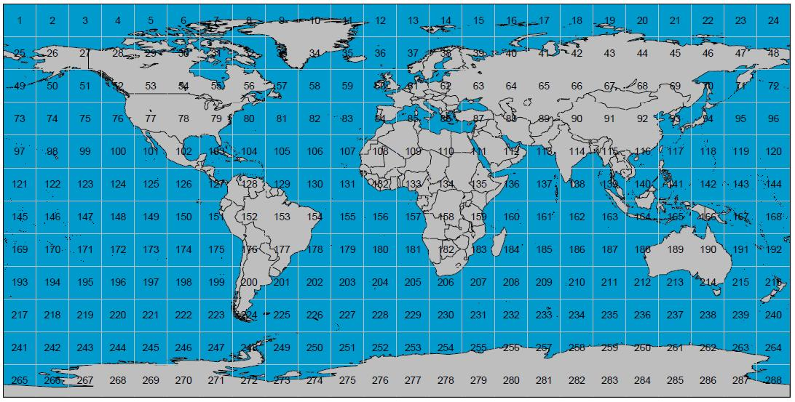

Figure 1. Graphical overview of model structure (base resolution)

## 2.3 Compartments

Each region can 10 homogeneous compartments (Figure 2). Compartments can contain sub-compartments which are in equilibrium among each other. For example there are biota and suspended particles in the oceans and air, water and solids in the soil compartment.

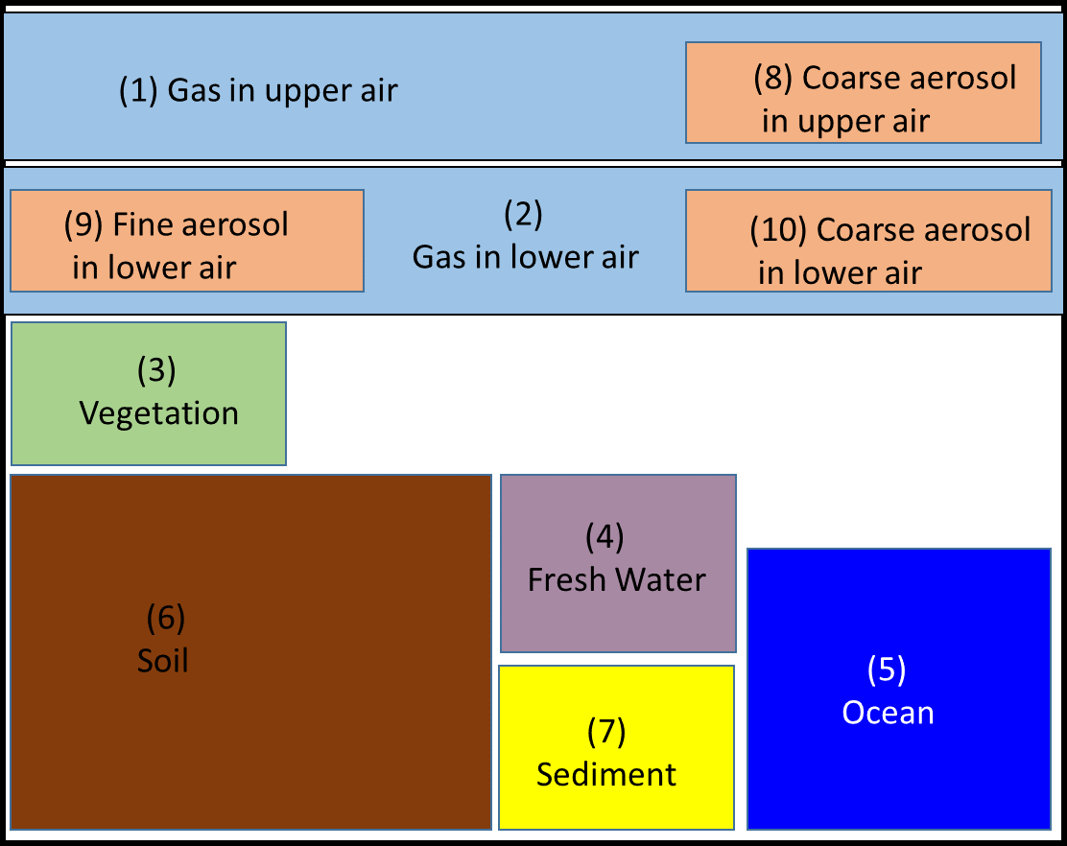

Figure 2. Compartments of BETR-Global

## 2.4 Mathematical formulation

Degradation of chemicals in cells and transport of chemicals between compartments are modelled as first-order processes. The transport equation for convective-dispersive transport in water and air is discretised in space. The spatial derivatives are approximated using two-point upwind differencing to yield a system of ordinary differential equations that describe the mass-balance of chemical in the global environment. Environmental conditions are assumed to be constant during each month of the year. The whole model can then be expressed as a system of first order linear ordinary differential equations with piecewise constant coefficients:

$\frac{dmass}{dt}=A_{m}mass+E$ (1)

where **mass** is the vector of contaminant masses in all cells, *A***m** is a square matrix containing the mass rate-constants of transport/degradation during month m, and **E** is the emission vector.

# Installation and Run BETR Global

BETR Global is written by Python 2.7 and runs/tests in Linux operator, so you need a Python 2.7 interpreter and several add-on packages for scientific computing.

**Step 1: Install Python 2.7 in Linux**

The latest version of Red Hat Linux and Ubuntu come with Python 2.7 out of the box. To see which version of Python you have installed, open the Terminal and run

Python --version

If there is no Python or the version is not 2.7, then run

$ sudo apt update

$ sudo apt upgrade

$ sudo apt-get install python 2.7

**Step 2: Install numpy, scipy and netCDF4**

$ sudo apt-get install oython-pip

$ sudo pip install numpy

$ sudo pip install scipy

$ sudo pip install netCDF4

**Step 3: Install odespy**

odespy module is a fast numerical ODE solver. Using this module allows much faster simulations.

$ sudo pip install -e git+https://github.com/hplgit/odespy.git#egg=odespy

**Step 4: Download BETR Global 4.0 and extract Files**

<https://github.com/BETR-Global/BETR-Global-4.0>

**Step 5: Run BETR Global 4.0**

The current run files in the above website are ‘runD5.GenNL_dyn_br.py’, ‘runBDE209.GenNL_dyn_br.py’ and ‘runBDE209.GenNL_dyn_hr.py’. You can of course write your own run files. Here, we take ‘runD5.GenNL_dyn_br.py’ as an example to show how to run BETR Global.

$ python runD5.GenNL_dyn_br.py

# References

1. Macleod, M.; Riley, W. J.; McKone, T. E., Assessing the influence of climate variability on atmospheric concentrations of polychlorinated biphenyls using a global-scale mass balance model (BETR-global). *Environmental Science & Technology* **2005,** *39* (17), 6749-6756.

2. Armitage, J. M.; MacLeod, M.; Cousins, I. T., Modeling the Global Fate and Transport of Perfluorooctanoic Acid (PFOA) and Perfluorooctanoate (PFO) Emitted from Direct Sources Using a Multispecies Mass Balance Model. *Environmental Science & Technology* **2009,** *43* (4), 1134-1140.

3. Armitage, J. M.; MacLeod, M.; Cousins, I. T., Comparative Assessment of the Global Fate and Transport Pathways of Long-Chain Perfluorocarboxylic Acids (PFCAs) and Perfluorocarboxylates (PFCs) Emitted from Direct Sources. *Environmental Science & Technology* **2009,** *43* (15), 5830-5836.

4. Lamon, L.; von Waldow, H.; MacLeod, M.; Scheringer, M.; Marcomini, A.; Hungerbuhler, K., Modeling the Global Levels and Distribution of Polychlorinated Biphenyls in Air under a Climate Change Scenario. *Environmental Science & Technology* **2009,** *43* (15), 5818-5824.

5. Chen, C. K.; Li, L.; Liu, J. Z.; Liu, J. G., Global environmental fate of short-chain chlorinated paraffins: Modeling with a single vs. multiple sets of physicochemical properties. *Science of the Total Environment* **2019,** *666*, 423-430.

6. Li, L.; Wania, F., Elucidating the Variability in the Hexabromocyclododecane Diastereomer Profile in the Global Environment. *Environmental Science & Technology* **2018,** *52* (18), 10532-10542.

7. MacLeod, M.; von Waldow, H.; Tay, P.; Armitage, J. M.; Wohrnschimmel, H.; Riley, W. J.; McKone, T. E.; Hungerbuhler, K., BETR global - A geographically-explicit global-scale multimedia contaminant fate model. *Environ. Pollut.* **2011,** *159*, 1442-1445.

8. Wohrnschimmel, H.; Tay, P.; von Waldow, H.; Hung, H.; Li, Y. F.; MacLeod, M.; Hungerbuhler, K., Comparative Assessment of the Global Fate of alpha- and beta-Hexachlorocyclohexane before and after Phase-Out. *Environmental Science & Technology* **2012,** *46* (4), 2047-2054.

9. Wohrnschimmel, H.; MacLeod, M.; Hungerbuhler, K., Emissions, Fate and Transport of Persistent Organic Pollutants to the Arctic in a Changing Global Climate. *Environmental Science & Technology* **2013,** *47* (5), 2323-2330.

10. Goktas, R. K.; MacLeod, M., Remoteness from sources of persistent organic pollutants in the multi-media global environment. *Environ. Pollut.* **2016,** *217*, 33-41.

11. McLachlan, M. S.; Undeman, E.; Zhao, F. Y.; MacLeod, M., Predicting global scale exposure of humans to PCB 153 from historical emissions. *Environmental Science-Processes & Impacts* **2018,** *20* (5), 747-756.

12. Bidleman, T. E., Atmospheric processes. *Environ. Sci. Technol.* **1988,** *22*, 361-367.

13. Cetin, B.; Odabasi, M., Atmospheric concentrations and phase partitioning of polybrominated diphenyl ethers (PBDEs) in Izmir, Turkey. *Chemosphere* **2008,** *71*, 1067-1078.

14. Cahill, T. M.; Mackay, D., Complexity in multimedia mass balance models: When are simple models adequate and when are more complex models necessary? *Environ. Toxicol. Chem.* **2003,** *22*, 1404-1412.

15. Seinfeld, J. H.; Pandis, S., Atmospheric Chemistry and Physics: from Air Pollution to Climate Change, Chapter 7. *John Wiley, New York,* **1998**.

16. Seinfeld, J. H.; Pandis, S., Atmospheric Chemistry and Physics: from Air Pollution to Climate Change. Chapters 7-8. *John Wiley, New York,* **1998**.

17. <https://www.esrl.noaa.gov/psd/cgi-bin/db_search/DBSearch.pl?Dataset=NCEP+Reanalysis&Variable=Precipitation+rate>.